**Lab 4: Inserting Initial Data into the Database**

**Insert Data in Program.cs**

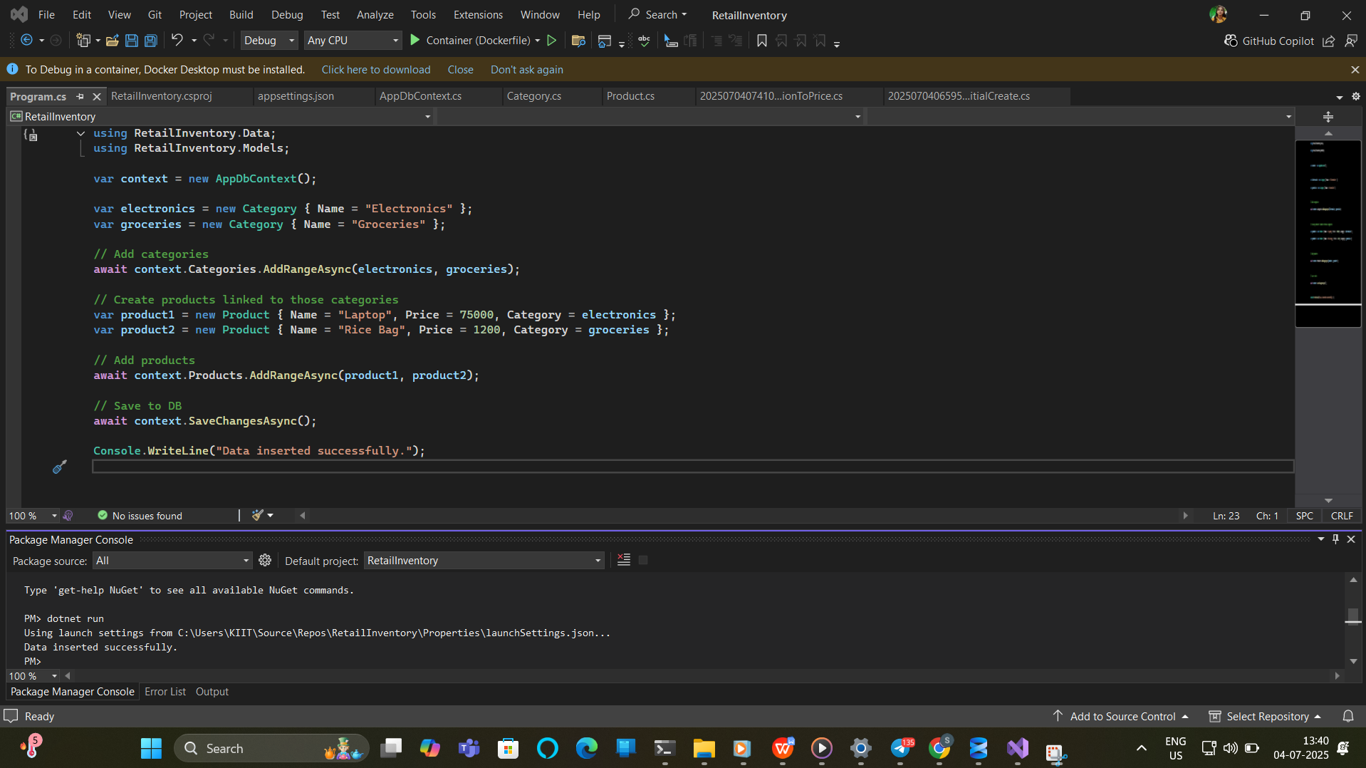

**Verify in SQL Server:**

